Part 1 - Single Colour Image and Its Combine Pattern

Terahertz pulsed spectroscopic imaging using optimized binary masks by Dr. Y.C. Shen was the foundation of this sub-task.

Brief Explanation:
Terahertz pulsed spectroscopic imaging (TPSI) using optimized binary masks is a technique that combines terahertz spectroscopy and compressed sensing to create high-resolution images of samples. Dr. Y.C. Shen and colleagues developed this technique to overcome the limitations of conventional terahertz imaging, which is often limited by low resolution and long image acquisition times.

In TPSI, terahertz radiation is used to interrogate a sample and create a time-domain signal, which is then processed using compressed sensing techniques to reconstruct an image. Compressed sensing is a mathematical framework that allows high-resolution images to be created from limited or incomplete data. This is achieved by exploiting the sparsity or compressibility of the signal being measured.

One way to implement compressed sensing in TPSI is to use optimized binary masks. These masks are designed to selectively measure certain features of the signal while discarding others. By doing this, the amount of data that needs to be acquired and processed is reduced, resulting in faster image acquisition times and lower data storage requirements. The use of optimized binary masks in TPSI has several advantages over other compressed sensing techniques. For example, binary masks are easy to implement and can be applied directly to the terahertz pulse signal without the need for additional hardware. Additionally, binary masks can be optimized for specific applications, allowing for the creation of high-resolution images with minimal data acquisition.

Single-pixel cameras (SPCs) are another application where optimized binary masks are commonly used. SPCs are a type of imaging system that uses a single detector element, or pixel, to capture images. This is achieved by projecting a series of optimized patterns onto the sample, which are then measured by the detector. By repeating this process with different patterns, an image can be reconstructed using compressed sensing techniques. SPCs have several advantages over traditional imaging systems. For example, they are more robust to noise and can operate in low-light conditions. Additionally, SPCs can be used for imaging applications where traditional cameras are not practical, such as imaging through fog or smoke.
The use of optimized binary masks is critical for the performance of SPCs. The patterns used to illuminate the sample must be carefully designed to maximize the amount of information that can be extracted from the measured signal. This is typically done by optimizing the binary masks using compressed sensing algorithms, such as iterative thresholding or basis pursuit.

In summary, terahertz pulsed spectroscopic imaging using optimized binary masks is a powerful technique for creating high-resolution images of samples. This technique combines terahertz spectroscopy and compressed sensing to reduce image acquisition times and improve resolution. Additionally, optimized binary masks are commonly used in single-pixel cameras to maximize the amount of information that can be extracted from the measured signal.

The flow chart is on the following:
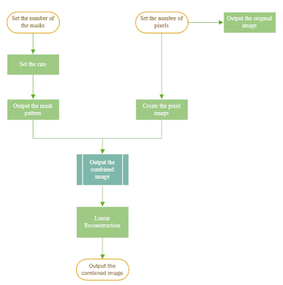

We observed that modifying the number of mask patterns impacted the reconstruction of the original image. Increasing the number of mask patterns improved the quality of the reconstruction, indicating a linear relationship between the number of mask patterns and the quality of the reconstructed image.

The result of the program with the mask pattern size 180 is below.

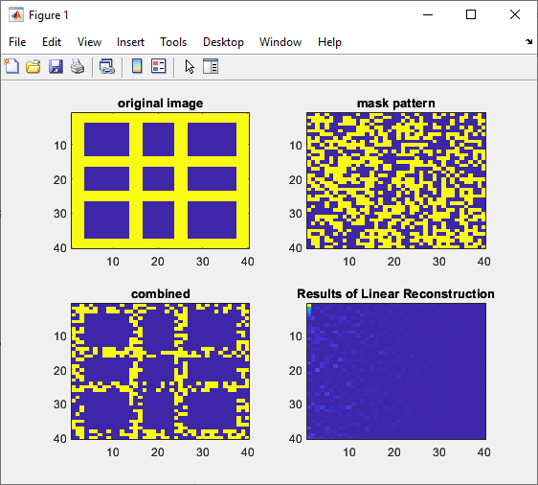

This is a MATLAB code that performs linear reconstruction of a terahertz image using Lasso regression. The code simulates terahertz measurement data by applying a set of binary mask patterns to a sample image. The THz data is then reconstructed using Lasso regression with a sparsity constraint to recover the original image. The sample image used in the code is a 40x40 binary matrix with white squares placed at specific locations to form a pattern. The number of masks used for the simulation is set to 180, and the mask patterns are generated randomly using a threshold of 0.5. The THz measurement data is obtained by multiplying the mask patterns with the sample image.

The linear_rec function is then called to perform the Lasso regression using the THz data and the mask patterns. The function first sets up the measurement matrix A with the mask data and then performs Lasso regression using the soft-thresholding method. The sparsity constraint is controlled by the regularization parameter lambda, which is set to 0.01 in this code. The maximum number of iterations is set to 1000, and the tolerance is set to 1e-3. The function outputs the reconstructed image in a 40x40 binary matrix format. The reconstructed image is refined by setting all negative values to zero, and then displayed using the imagesc function. The reconstructed image is then compared to the original sample image to evaluate the quality of the reconstruction.
This code can be modified to simulate a single pixel camera by using only one binary mask pattern instead of 180. In a single pixel camera, the image is reconstructed by sequentially measuring the intensity of the image using a single detector and a random binary pattern. The intensity measurements are then used to recover the image using compressive sensing techniques such as Lasso regression. The single binary mask pattern used in a single pixel camera can be randomly generated or pre-designed, and the THz measurement data can be obtained by taking the inner product of the mask pattern and the image. The reconstructed image can then be obtained using the same linear_rec function as used in this code.

Part 2 - Common Image with Its Reconstruction
Used MATLAB to create a simple image containing 1600 pixels. The masks of the image increased from 100 to 1650 and the quality of the linear reconstruction varied with the masks increasing.

Writes a function to pass the parameter of the mask numbers so the function can call the parameter to do different reconstruction of different mask patterns. When the mask number is less than the total pixels of the image, the quality of linear reconstructed image becomes better as the mask number increased. If the mask number exceeds the pixels, the linear reconstruction cannot complete.
The result can be seen on the following figure below.

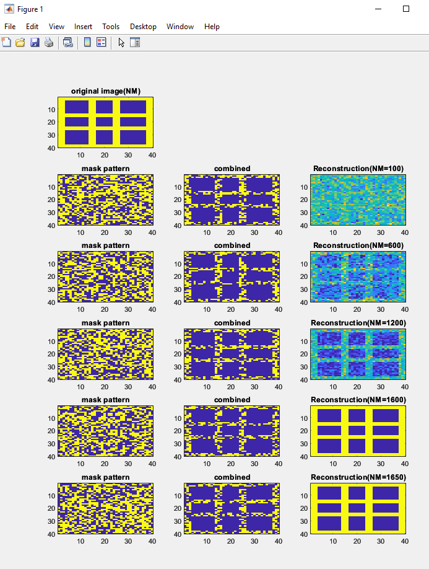

Part 3 - Reconstruction of Real Image

As a student, I attempted to reconstruct a real image with different colors using MATLAB. To read the image data, I used the imread() function. My approach was to reconstruct the image directly.
First, I read the image and stored the data of each point in a matrix. Then, I set the numbers of the mask pattern using the numbers of pixels, as this has been shown to result in the best quality of reconstruction. Next, I obtained the THz data and combined them to do the linear reconstruction. To compare the reconstructed image with the original image, I used a simple function that compares the pixels of two different images. However, I encountered some problems during the reconstruction process. First, the image had to have equal length and width, and the number of pixels had to be n × n. Second, MATLAB has its own limit on the size of the matrix, so if the image was too large, the reconstruction work could not be done.
Overall, my flowchart for the reconstruction process looked like this:

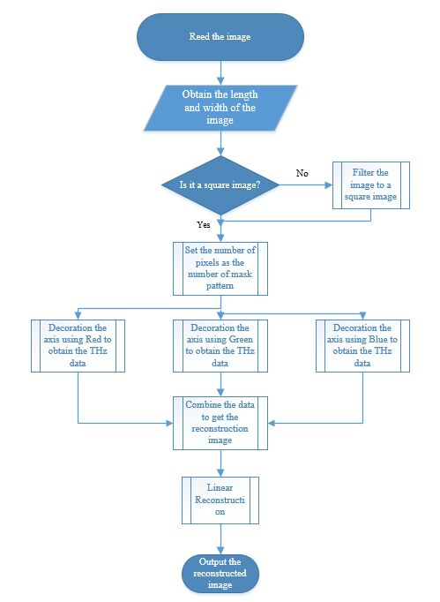
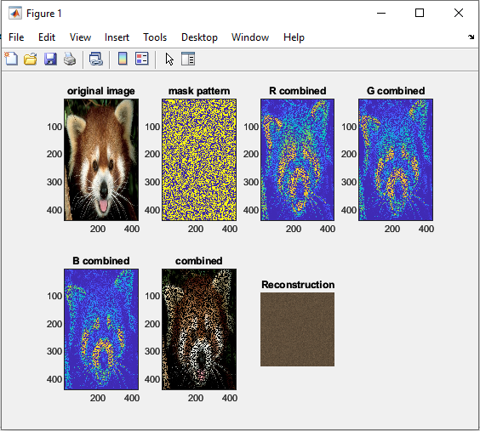

Next Part will try some other solutions to deal with large images.

Part 4 - Reconstruction with Large Image with Dividing the Image

This part focused on 3 Aspects in relation to the project –
- How to divide the large image, whose pixels exceed 1000*1000 approximately. For this part, our group use MATLAB to reads the image and get the data, then compressed the image to achieve the equal length and width. Then divide the image into small blocks which are 160*160, then for each block, we do the reconstruction, at last, we combined the image. In this process, we met some dilemma.

- The sampling rate ([0,1]) in reconstructed image. We tried to find the relationship between the sampling rate and the reconstructed quality. The relationship can be described on 2 following for a certain image:

- If the number of masks is fixed, the higher sampling rate, the better reconstructed quality will be attained.
- If the sampling rate is fixed, the higher number of masks (which does not exceed the pixels of the original image), the better reconstructed quality will be attained.

- How to compare the original image and the reconstructed image. We used the function called ssim(image, new_image), it would return a value which is between 0 and 1, if the value is nearer to 1, the reconstructed quality would be better.

First Part –
For the first part, dealing with large image. Our group modify the reconstruction part into one function, linear_reconstruction(new_image), which pass the image as the parameter. When trying to do the reconstruction for one specific part for the first time, MATLAB returns the area with black colour. But when tring the divide, reconstruction and combine of a small image, it was successful. Which means the algorithm of the divide has no problem.

Second Part –
Changing the sampling rate in the reconstruction process.
Here are examples of fixed number of masks, different sampling rate with the similarity between the original image and reconstructed image:

160*160 pixels with 0.2 sampling rate - The similarity is 0.7850
160*160 pixels with 0.4 sampling rate - The similarity is 0.8594
160*160 pixels with 0.6 sampling rate - The similarity is 0.9099
160*160 pixels with 0.8 sampling rate - The similarity is 0.9583
160*160 pixels with 1.0 sampling rate - The similarity is approximately 1

Under this situation, if number of masks is fixed, the higher sampling rate, the better reconstructed quality.

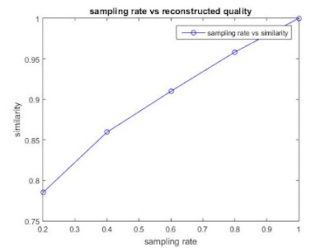

Under this situation, if sampling rate is fixed, the higher number of masks, the better reconstructed quality

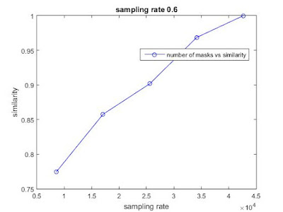

Part 5 – GUI
In part 4, The block size was 160*160 and we compressed the image to let it have the same length and width, which are the actual times of 160. We found that the process speed is very low and it takes us approximately 27 hours to deal with a 1920*1200 image. And the result returns with black image.

Investigate and work on the following parts –
- Optimize the code in dividing image, after the reconstruction process, the program will not return a black block.
- Create a GUI program to implement the process of the image.

First Point:
Tried to divide the large image into very small parts, for example, the 10*10 block or 20*20 block. From this I found some small conclusions on the following:

- In this project, the process is mainly about matrix calculation. For the 160*160 block, the program needs to generate one matrix, which has the (number of masks)*(the square of block length). The complexity of the program is O(n^2). n is the length of the small block. When the length of the square decreased from 160 to 20, the order of magnitude decreased approximately 1. Then the speed decreased about 2 order of magnitude. The process speed for one block image increased a lot.

- Assume the time consumed is t, then t = n*s. In this equation, n is the number of the blocks, the s is the time consumed in processing one block. The s decreased for n is bigger. For example, when the block length decreased from 160 to 20, the n increased about one order of magnitude, but s decreased about 2 order of magnitude. This shows that the speed will not increase as the block numbers become more, when n reaches one approximately value, the time consumed will becomes the maximum. According to our timer, the time when the block length is equal to 10, the time consumed is slightly more than when the block length is 20.

For the 2 aspects, our group summarizes the conclusion roughly and illustrate the relationship between the time consumed and the number of blocks for one fixed graph (1920*1200).

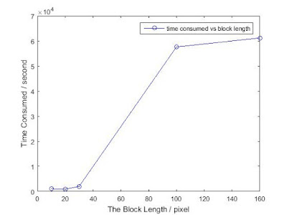

This part we defined a parameter r, which is number of masks N over the square of block length l. r = N/(l^2). r is in the interval (0,1]. For r approaches 1 more, the quality of the reconstruction is better. Which means they have higher similarity. The conclusion between the rate and the similarity is that if the rate increased, the similarity is higher for there are more masks pattern and ensure the better combine quality.

